Example Model changes in 4.2.3

- Operations package is added
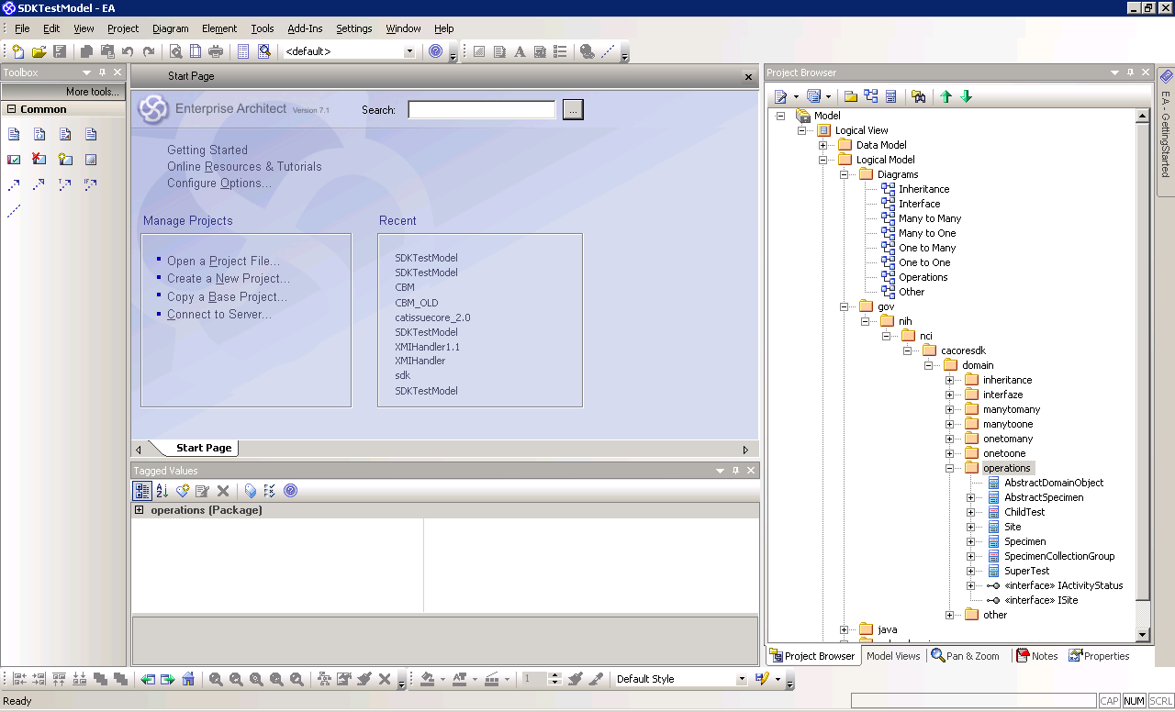

- Bi-directional self associations
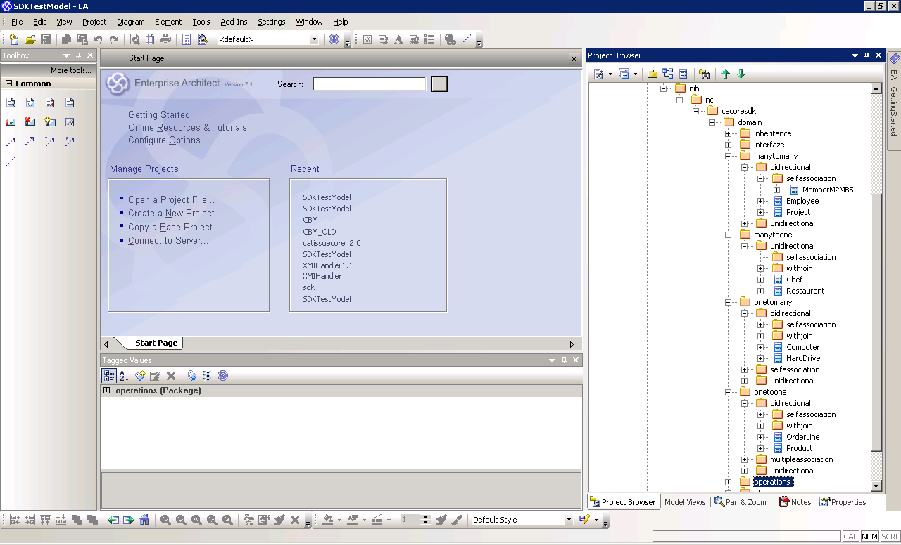

- Data model elements for Bi-directional self association
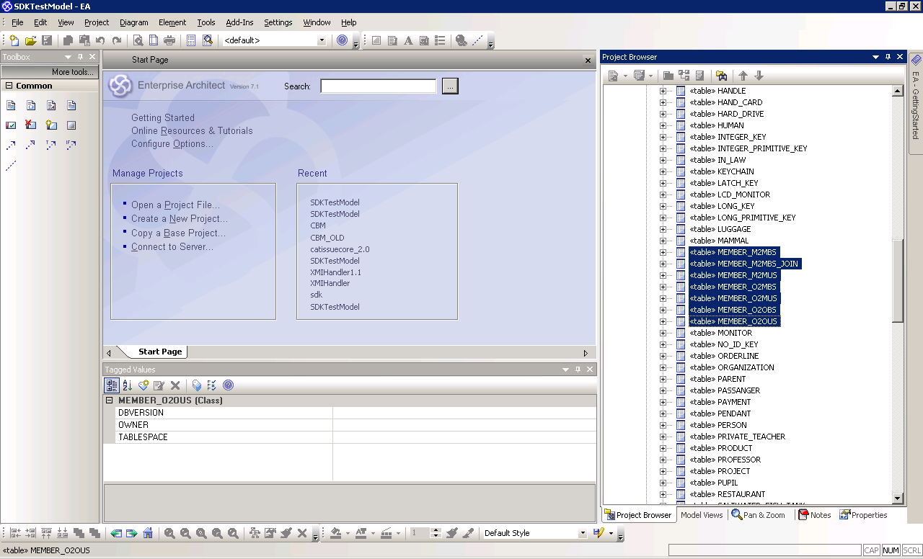

- Following elements are added to Data model for Operations
SUPER_TEST
CHILD_TEST
SPECIMEN
SPECIMEN_COLLECTION_GROUP
ABSTRACT_SPECIMEN
SITE

- Logical model diagram for operations
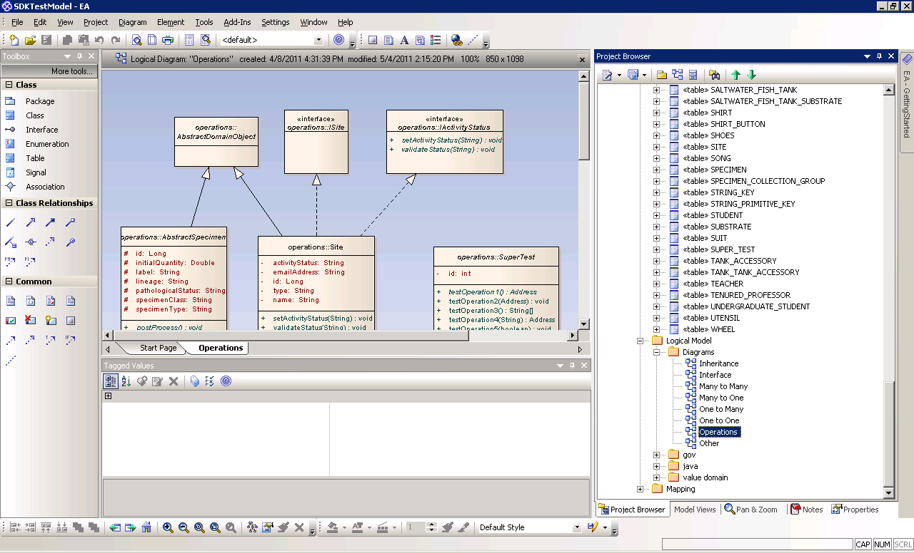

- Update existing following logical model diagrams for bi-directional self associations
Many to many
One to many
One to one

- Data model diagram for operations
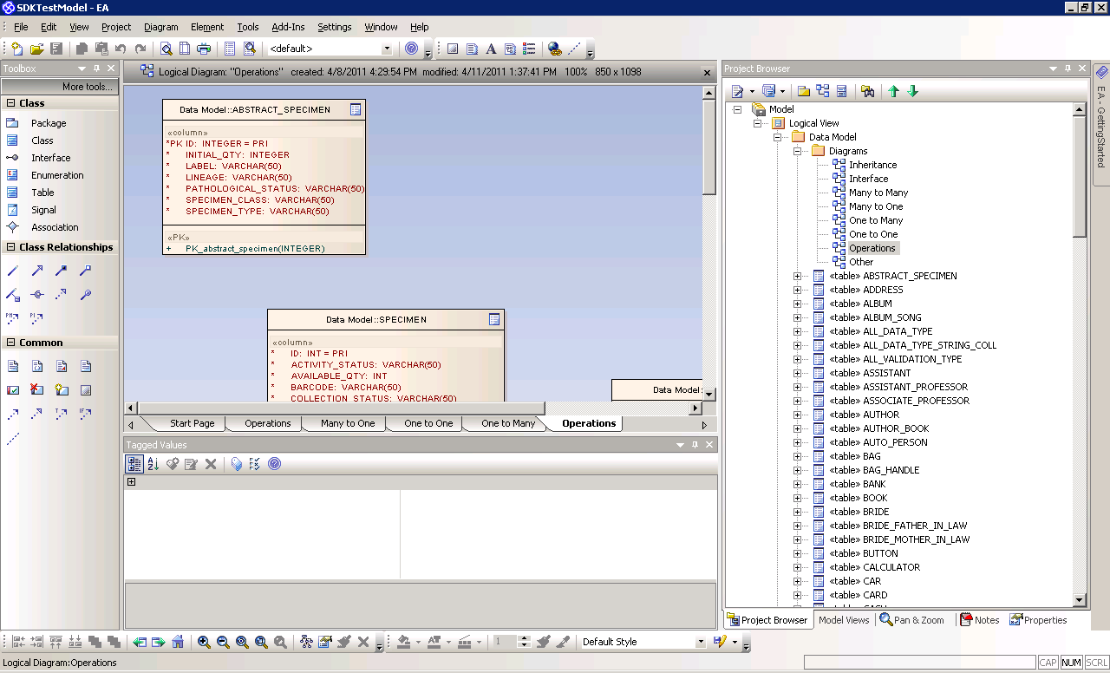

- Update existing following data model diagrams for bi-directional self associations
Many to many
One to many
One to one

- Update entity operation behavior

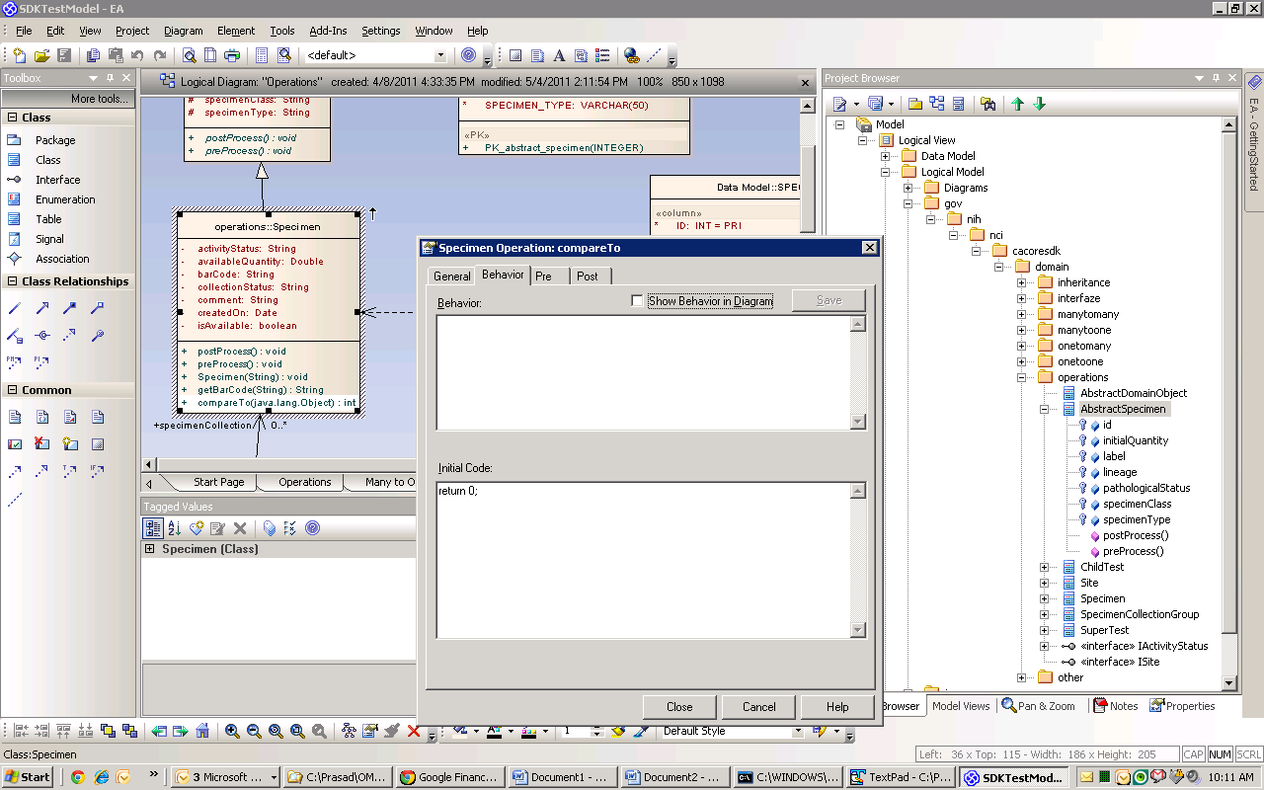

- Make sure to verify documentation, throws tags
